Level 2
PROMPT sheet

2/1 To count by grouping

Example1: Here are 20 sweets to share
Each child gets 5 sweets
How many children are there?

Divide them up into groups of 5 sweets-like this

There must be 4 children

Example2: Here are 12 marbles to share
There are 4 children.
How many marbles does each get?

Divide them up into 4 groups - like this

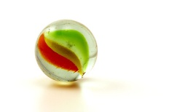

Each child gets 3 marbles

2/2 To order numbers

Numbers can be ordered by looking at the value of each digit
Example:
To order 83 3 87 8 80 78
Tens Units
T U
8 3
0 3
8 7
0 8
8 0
7 8
The order would be;
3 8 78 80 83 87
smallest largest

2/3 Numbers sequences

Look to see what you already know
Example1: 1 4 7 10 ..... .....
+3 +3 +3
- The numbers are going up- ascending
- They go up by 3 each time
- Continue with this rule

1 4 7 10 13 16
+3 +3

Example1: 13 11 9 7 ..... .....
-2 -2 -2
- The numbers are going down - descending
- They go down by 2 each time
- Continue with this rule-count backwards
13 11 9 7 5 3
-2 -2

2/4 Know the 2, 5, 10 times tables

1 | x | 2 | = | 2
2 | x | 2 | = | 4
3 | x | 2 | = | 6
4 | x | 2 | = | 8
5 | x | 2 | = | 10
6 | x | 2 | = | 12
7 | x | 2 | = | 14
8 | x | 2 | = | 16
9 | x | 2 | = | 18
10 | x | 2 | = | 20
1 | x | 5 | = | 5
2 | x | 5 | = | 10
3 | x | 5 | = | 15
4 | x | 5 | = | 20
5 | x | 5 | = | 25
6 | x | 5 | = | 30
7 | x | 5 | = | 35
8 | x | 5 | = | 40
9 | x | 5 | = | 45
10 | x | 5 | = | 50

1 | x | 10 | = | 10
2 | x | 10 | = | 20
3 | x | 10 | = | 30
4 | x | 10 | = | 40
5 | x | 10 | = | 50
6 | x | 10 | = | 60
7 | x | 10 | = | 70
8 | x | 10 | = | 80
9 | x | 10 | = | 90
10 | x | 10 | = | 100

2/5 Work out halves and quarters

To work out a half
Split into two equal parts
YES NO!!!!
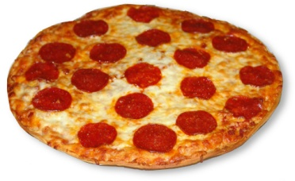

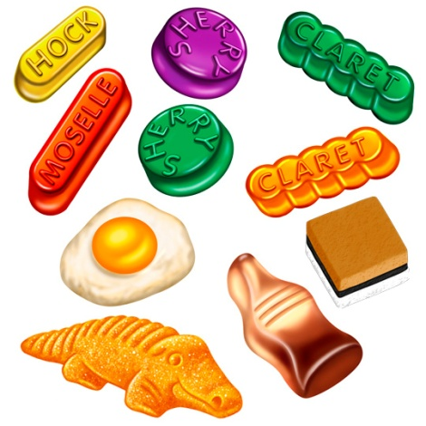

10 sweets ÷ 2 = 5 sweets
To work out a quarter
Split into four equal parts

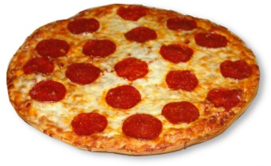

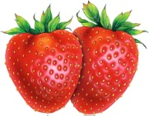

8 strawberries ÷ 4 = 2 strawberries

2/6 Subtraction is the inverse of addition

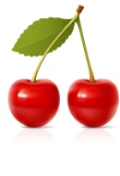
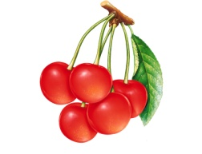
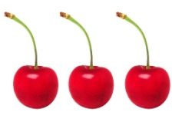
=
+

3 + 2 = 5

-

5 - 2 = 3
-

5 - 3 = 2

Matching subtraction facts for an addition sum

3 + 2 = 5

- - 2 = 3 5 - 3 = 2

- + 4 = 10

10 – 6 = 4 10 – 4 = 6
2/7 Halving as a way of undoing doubling

3 DOUBLE 6
5 10

3 HALF 6
5 10

2/8 Number bonds (Friends) to 10

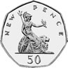
 |  |  |  |  |  |  |  |  | 10
1 |  |  |  |  |  |  |  |  | 9
 | 2 |  |  |  |  |  |  |  | 8
 |  | 3 |  |  |  |  |  |  | 7
 |  |  | 4 |  |  |  |  |  | 6
 |  |  |  | 5 |  |  |  |  | 5
 |  |  |  |  | 6 |  |  |  | 4
 |  |  |  |  |  | 7 |  |  | 3
 |  |  |  |  |  |  | 8 |  | 2
 |  |  |  |  |  |  |  | 9 | 1

0 + 10 | 1 + 9 | 2 + 8 | 3 + 7 | 4 + 6
10 + 0 | 9 + 1 | 8 + 2 | 7 + 3 | 6 + 4
 |  | 5 + 5

These are so good to learn – believe me

2/9 Mental calculation strategies

DOUBLES – you should know all of them
Double 1 (1 + 1) = 2 OR 2 x 1 = 2
Double 2 (2 + 2) = 4 OR 2 x 2 = 4
Double 3 (3 + 3) = 6 OR 2 x 3 = 6
Double 4 (4 + 4) = 8 OR 2 x 4 = 8
Double 5 (5 + 5) = 10 OR 2 x 5 = 10
Double 6 (6 + 6) = 12 OR 2 x 6 = 12
Double 7 (7 + 7) = 14 OR 2 x 7 = 14
Double 8 (8 + 8) = 16 OR 2 x 8 = 16
Double 9 (9 + 9) = 18 OR 2 x 9 = 18
Double 10 (10 + 10) = 20 OR 2 x 10 = 20

Another double
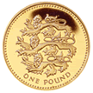
+ =

2/10 Repeated addition (Multiplication)

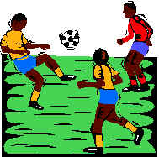
Here are 3 footballers.
How many legs do they have altogether?

Addition sentence Multiplication sentence
2 + 2 + 2 = 6 3 x 2 = 6

Repeated addition is the same as multiplication

Addition sentence | Multiplication sentence
5 + 5 + 5 + 5 = 20 | 4 x 5 = 20
10 + 10 + 10 = 30 | 3 x 10 = 30

2/10 Repeated subtraction (Division)
Repeated subtraction is the same as division

15
This is the same as 15 ÷ 5 = 3

Because 5 has been subtracted 3 times to get to 0
-5 (1)
10
-5 (2)
5
-5 (3)
0

2/11 Solve number problems

- The order can be changed
Example:
13 + 6 + 7 = 13 + 7 + 6 = 20 + 6 = 26

- The number can be partitioned
Example:
10 + 15 = 10 + 10 + 5 = 20 + 5 = 25

- A partial number line can be used
Example:
37 + 8 = 45

⁺⁸
⁺³ ⁺⁵

37 40 45

22 – 3 = 19
⁻¹ ⁻²

19 20 22

2/12 Record work as a number sentence

Example 1
There are 12 people on a bus.
At the next stop 4 people get off and 7 get on
How many are on the bus now?
Number sentence
12 – 4 + 7 = 15

Example 2
Pavan’s cat weighs 18kg. Olivia’s dog weighs 32kg. How much heavier is Olivia’s dog?
Number sentence
32 – 18 = 14

Example 3
Sana had 50p. She spent 24p. How much did she have left?
Number sentence
50 - 24 = 26p

Example 4

Aabid has 20p and Claudia has 41p. How much do they have altogether?
Number sentence
20 + 41 = 61p

2/13 Names of 2D shapes

Triangle Square Pentagon

Hexagon Circle Octagon

2/13 Names of 3D shapes

cube cylinder cuboid
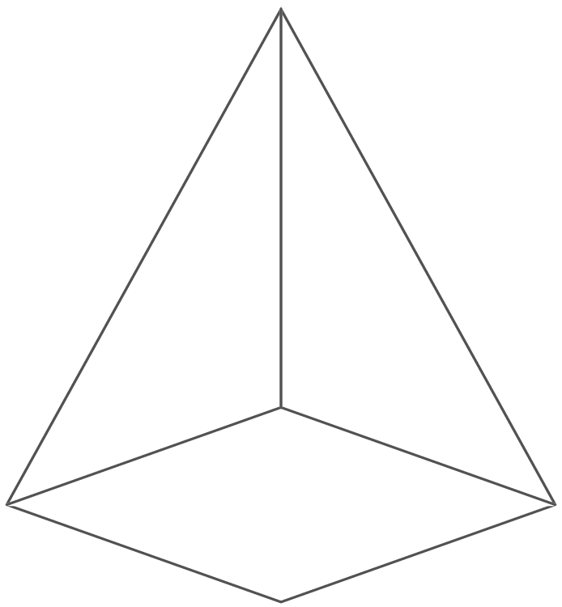
pyramid sphere

2/14 Properties of shapes

corner edge face

curved surface

2/15 Describe position of objects

The yellow square is above the orange cylinder
The sphere is to the left of the pink hexagon
The blue cuboid is below the red circle
The cuboid is to the right of the orange cylinder
2/16 & 17 Describe position of objects

A quarter turn
clockwise

A quarter turn
anti-clockwise

A half turn

2/18 Use measures

METRIC units of length are:
Millimetre (mm)

Centimetre (cm)

Metre (m)

Kilometre (km)

2cm = 20mm 4.5cm = 45mm
1cm = 10mm
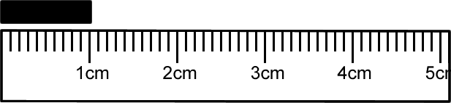

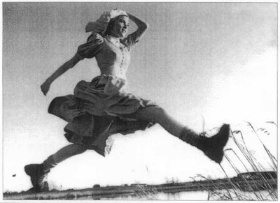

- A big stride is about a metre

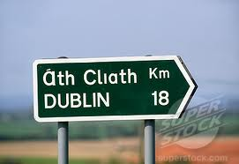

- Distance to Dublin is measured in kilometres

METRIC units of weight are:
Gram (g)

Kilogram (kg)

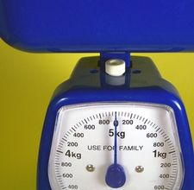

1 kilogram(kg) = 1000grams(g)
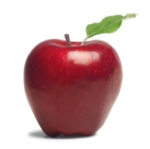

- An apple weighs 150grams

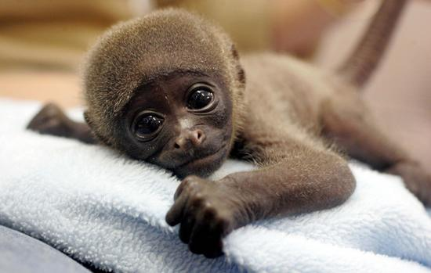

- Baby chimp weighs 3kg

METRIC units of capacity (liquids) are:
Millilitre

Centilitre

Litre

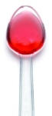
- A medicine spoon holds 5ml

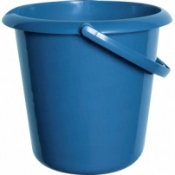
- A 5-litre bucket

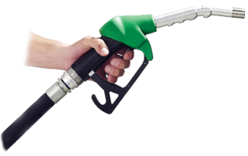

- Fuel for the car is measured in litres

2/19 Sorting

Carroll Diagram to sort these numbers:
26 5 14 30 55 8 35 37

 | Multiples of 5 | NOT multiples of 5
Less than 30 | 5 | 26 14 8
NOT less than 30 | 30 55 35 | 37

Venn Diagram to sort these shapes

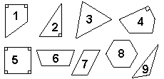
Set R contains shapes with a right-angle (90°).
Set Q contains shapes with four sides.

R Q

6 3
2 1 5
4 7 8
9

2/23 Record & communicate findings
- Frequency table of recycling
Item | Frequency (tally) | Total
Plastic | l l l l 1111 | 10
Glass | 1111 | 4
Cardboard | 1111 1 | 6
Recyclable steel | l | 1
Aluminium cans | l l l l 11 | 7
Other | l l l l 1111 | 9

- Bar chart of animals kept

- Pictogram of football teams

KEY: Each badge represents 2 people

Manchester Utd
Darlington
Liverpool
Newcastle

- Reading the pictogram using the key we have:

Manchester = 6 people
Darlington = 10 people
Liverpool = 3 people
Newcastle = 8 people

